ParkEase Project Contribution Report

Name : Sakshi Vikram Shinde

Role : Backend Developer

Introduction
I worked on the ParkEase project focusing mainly on backend development and system integration. My responsibilities included implementing key features such as user registration, login authentication, and the owner dashboard, along with contributing to database schema design.

Key Contributions

1. Registration Module
Developed the backend logic for user registration using Spring Boot. Integrated the registration module with the frontend and database during the first milestone.

2. Login & Authentication
Implemented login functionality with JWT-based authentication to ensure secure access. Completed full integration of login and registration features during the second milestone.

3. Owner Dashboard
Designed and implemented the backend for the owner dashboard. This includes features like adding parking spaces, managing slots, and full database integration. This work was completed during the third milestone.

4. Database Contribution
Actively contributed to designing the database schema to support application functionality efficiently.

Milestones Summary
First Milestone: Integrated registration backend with frontend and database.
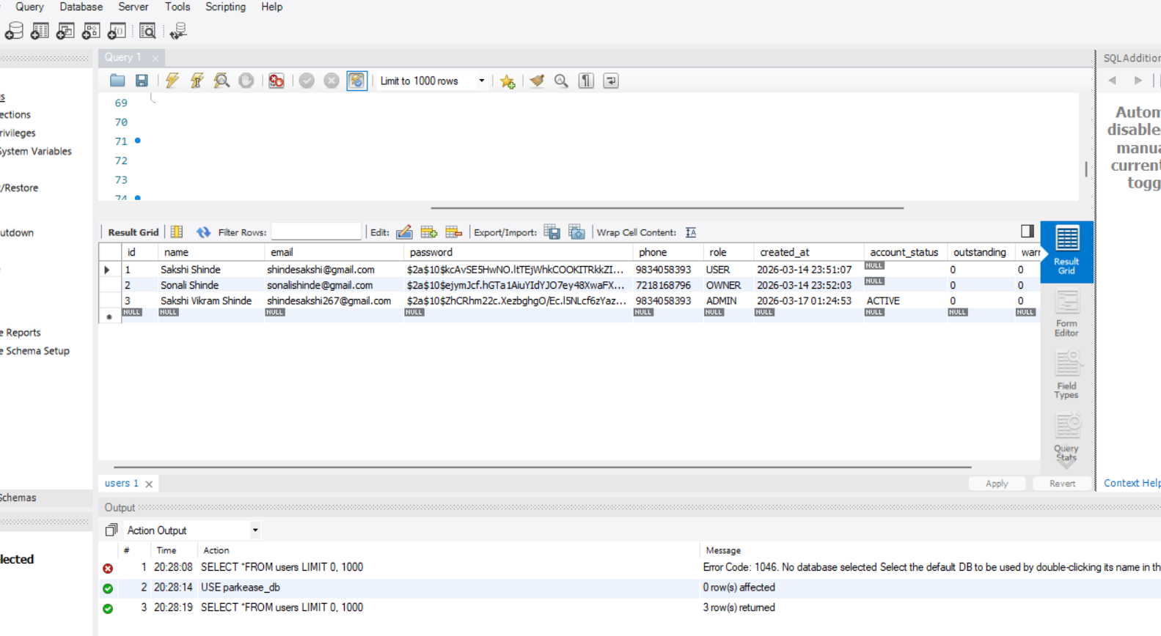
Second Milestone: Completed login, registration, and JWT authentication.
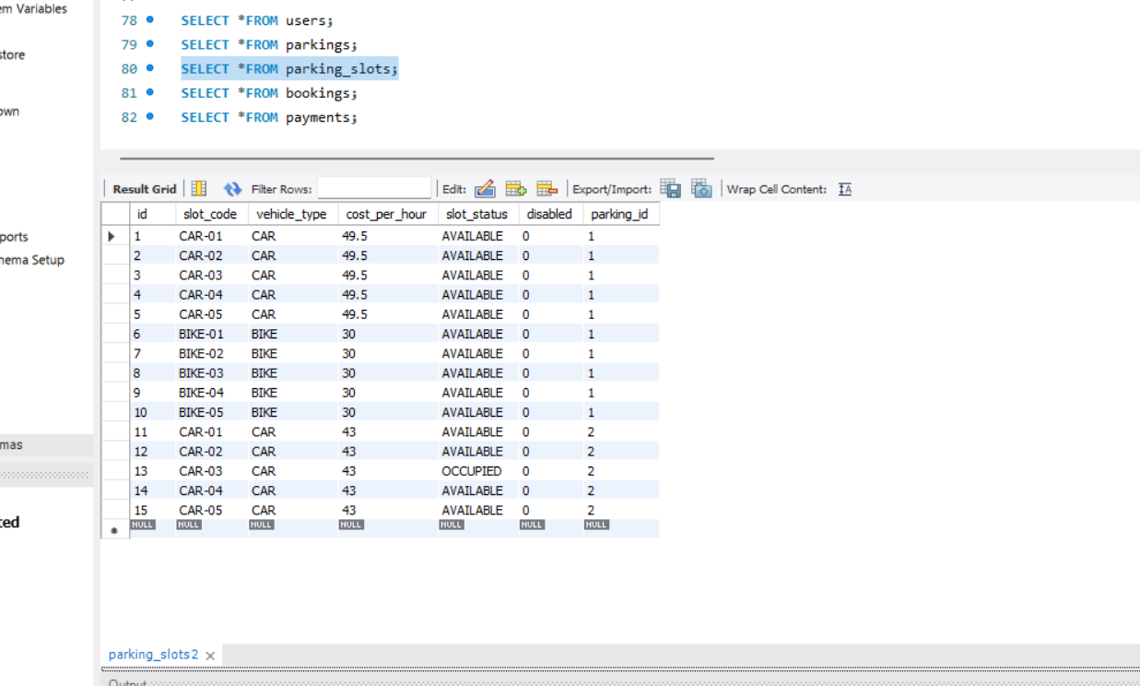
Third Milestone: Completed full owner dashboard integration including parking and slot management.

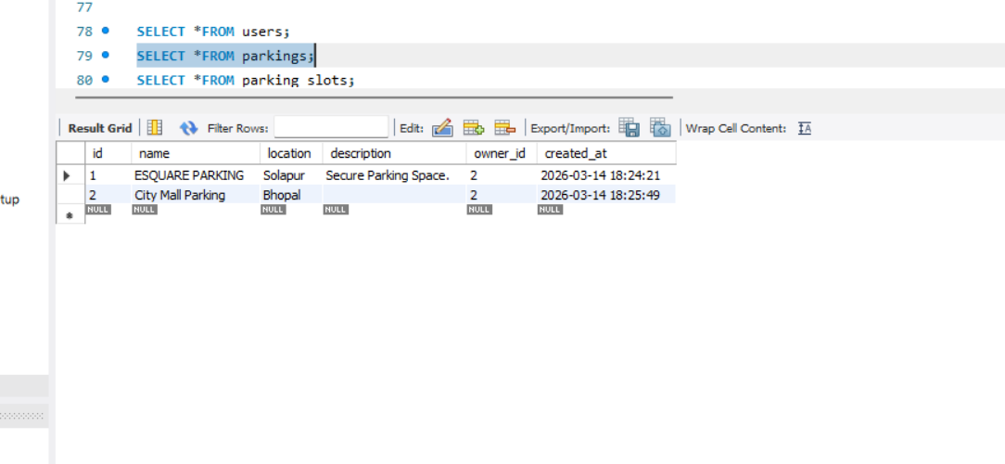

Tools & Technologies Used
MySQL for database management.
IntelliJ IDEA for backend development using Java Spring Boot.
VS Code for frontend development.
Postman for API testing.

